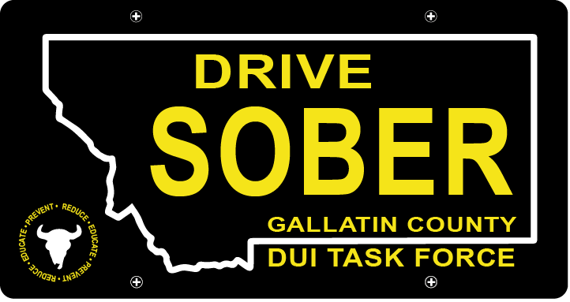

Gallatin County DUI Task Force

Meeting

September, 15th, 2021

Gallatin County Attorney’s Office:
1709 W. College St
Bozeman, MT
59715
Or Online with link

- Call to order
  - Coordinator, Leah Mobley
  - Introductions
  - July Minutes Approval
- Update – Leah Mobley, Coordinator
  - Merchandise Order
    - Volunteer Shirts, koozies, etc.
  - Advertising
    - Student Survival Kit
    - Blue Light Guide by Outside Bozeman Mag
  - Reviving the PI&E Committee
    - Needing more volunteers to bring it back
  - Geo-fencing
  - Catapalooza
  - Music on Main
  - Sober Sister Program (Forrest McKai- Think Twice)
- New business
  - Madison County DUI Prosecution Training
    - Link
    - LE officers attending the Prosecution training will receive 8 hours of POST credit
  - Annual Transportation Safety Meeting
    - October 4th & 5th
    - Virtual Platform, with link to come
  - Volunteer Sign Ups
    - Best practices for signing up?
    - What events do people want to volunteer at?
    - What event are important for us to be at?
  - Upcoming Events
    - Homecoming Tailgate- October 9th
    - Christmas Stroll- December 4th
    - Other Events
- Public Comment
  - Forrest
- Adjournment
Adjourned meeting at _________.

