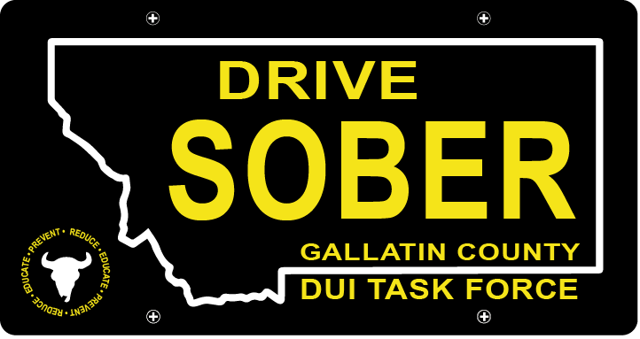

Gallatin County DUI Task Force

Meeting

October 13, 2022 @ 5:30 pm
Gallatin County Attorney’s Office: 1709 W College, Bozeman, MT

- Call to order
- Update – Coordinator Vacancy/Hiring
  - Member Update
  - Events – On Hold
  - DUI Report - Update
- New business
    - Misdemeanor DUI Court – Judge Herrington & Renee Boundy, VETS Court Coordinator, Bozeman municipal Court
- Public Comment
- Adjournment
Adjourned meeting at _________.

