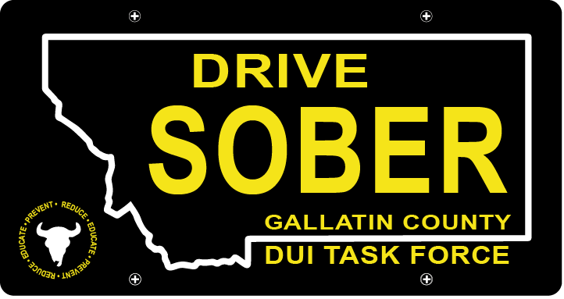

Gallatin County DUI Task Force

Meeting

November 18, 2020 @ 5:30 PM

Join Google Meet
https://meet.google.com/rhn-xnae-gxq

- Call to order
  - Katy Fritz, Chair
  - Virtual Introductions
- Update – Leah Mobley, Coordinator
  - Think Twice
  - TikTok competition with Missoula County Task Force
  - Membership expiration (continued discussion from last meeting)
- New business
  - Passage of the I-190 Cannabis legalization.
    - Taking a public stance on this
    - Legislative advocacy efforts?
  - Vision Zero // Comprehensive Highway Safety Plan
  - Recruitment efforts for new members
  - Seeking someone to fill Katy’s executive spot as she transitions out in the New Year.
- Open Comment
  - Continue seeking new ways to reach people in times where events are restricted.
- Adjournment
Leah Mobley adjourned the meeting at _________.

