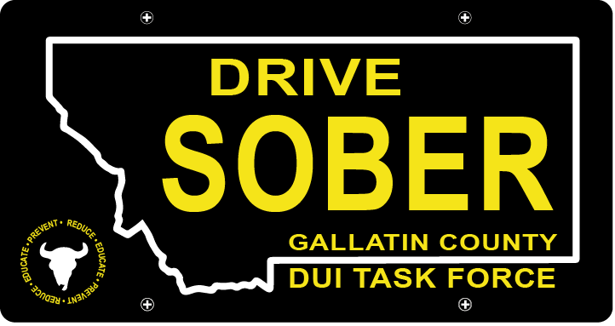

Gallatin County DUI Task Force

Meeting

Thursday, November 17, 2022 @ 5:30 pm
Gallatin County Detention Center Community Room: 605 S 16th Ave, Bozeman, MT

Join Zoom Meeting
Meeting ID: 981 6910 6291
Passcode: DUITF22

- Call to order
- Approval of Minutes
- Update
  - Hali Kapperud - Coordinator Introduction
  - Member Update
  - Events – On Hold
  - DUI Report – Update
  - CEASE Award Approval
- New business
    - January elections
      - Nominations for Executive Committee
    - Task Force Structure Discussion
      - Where do we want to go?
      - What do we want to do?
    - Membership
      - Brainstorm ideas to recruit members
        - Media Blitz?
    - Award Ceremony
- Public Comment
- Adjournment
Adjourned meeting at _________.

