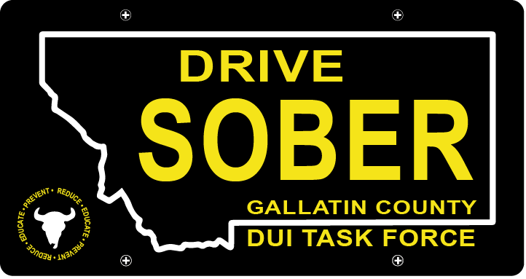

Gallatin County DUI Task Force

Meeting

November 17th, 2020

Gallatin County Attorney’s Office:
1709 W. College St
Bozeman, MT
59715
Or Online with link

- Call to order
  - Coordinator, Leah Mobley
  - Introductions
  - September Minutes Approval
- Update – Leah Mobley, Coordinator
  - Merchandise Order Received
    - Volunteer Shirts handing out
  - Advertising
    - Student Survival Kit
    - Blue Light Guide by Outside Bozeman Mag
  - Reviving the PI&E Committee
    - Needing more volunteers to bring it back
  - Annual Transportation Safety Meeting
    - Vision Zero
- New business
  - Annual Transportation Safety Meeting Review
    - October 4th & 5th
  - Volunteer Sign Ups
    - Best practices for signing up?
    - What events do people want to volunteer at?
    - What event are important for us to be at?
  - Upcoming Events
    - Christmas Stroll- December 4th
      - Activities
      - Handouts
      - Volunteers
    - Next Meeting in January
  - Funding the video project for
    - social media campaign
    - local news station
    - MSU orientation curriculum
  - MSU Spring Intern
  - Survey
    - Break time to fill out and give feedback
- Public Comment
- Adjournment
Adjourned meeting at _________.

