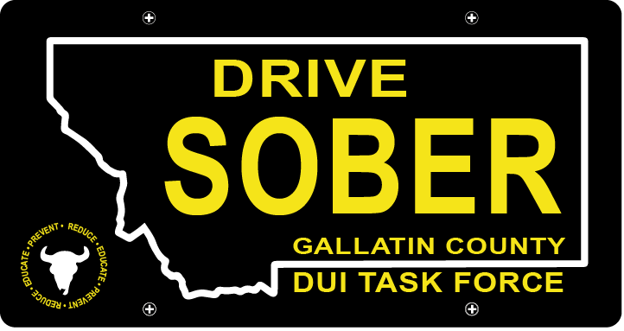

Gallatin County DUI Task Force

Meeting

May 19, 2021

Join Google Meet
https://meet.google.com/rhn-xnae-gxq

- Call to order
  - Coordinator, Leah Mobley
  - Virtual Introductions
  - March minutes Approval
- Update – Leah Mobley, Coordinator
  - PI&E committee revival
    - Email sent out to find a time
    - Meeting on a bi-monthly basis, but will increase to a monthly frequency if necessary
    - Focusing on the video project for the summer, and securing the grant for that
  - DUI Legislative victories & losses
    - Three DUI Bills passed this session. HB478 and HB115 both include coordination with SB365 (DUI Code reorganization).
      - SB365 – Generally revise and reorganize driving under the influence laws.
      - HB478- Generally Revise DUI Laws.
      - HB115 - Increase penalties for 5th and subsequent DUI.
      - HB701 – Generally revise marijuana laws.
    - Other Bills that we have been watching and passed.
      - HJ10 - Provide for an interim study regarding autonomous vehicle use in Montana.
      - HB 226 – Generally revise alcohol laws to provide for curbside pickup.
      - SB 129 - Generally revise alcohol laws relating to department investigations.
      - HB 256 – Revise Child Restraint Laws.
      - SB 9 – Provide for motorcycle filtering.
- New business
  - Bylaw changes
    - Updates to better support the infrastructure of the DUI Task Force
    - Reflective of the participation we expect based on trends from the last few years.
  - Grant for video project
    - Applying in July (new fiscal year)
  - Events Picking back up
    - Catapalooza
    - Music on Main
    - Local concerts
  - Future Meetings
    - Meeting in person
    - Online public option
- Public Comment
- Adjournment
Adjourned meeting at _________.

