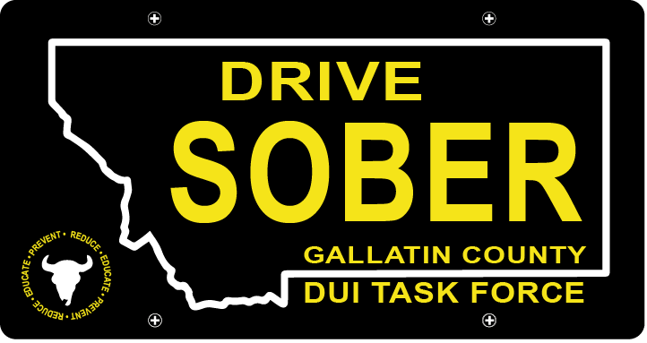

Gallatin County DUI Task Force

Meeting

May 18th, 2022 @ 5:30 pm

Gallatin County Attorney’s Office:
Or Online with link

1709 W. College St
Bozeman, MT
59715

- Call to order
  - Coordinator, Anna Ewen
  - Introductions
    - Meet Anna
    - Meet the Task Force
  - March Minutes Approval
- Update – Anna Ewen, Coordinator
  - Transition update
    - Anna Hired
    - Website has been uploaded
  - Strategic Plan
    - Approved by commission 4/19
    - Sent to state coordinator 4/28
  - Student Video Project
    - Present the films for the task force
    - Discussion on how we should go about releasing them
      - Social media Local News stations MSU debut
      - Where else can we utilize these?
  - Officer awards handed out in April
    - Discuss & strategize next year’s planning for something larger and more extravagant
- New business
  - Summer Events
    - Volunteers Needed
    - Catapalooza
    - Music on main
    - Any other ideas as we look to the summer events?
- Public Comment
- Adjournment
Adjourned meeting at _________.

