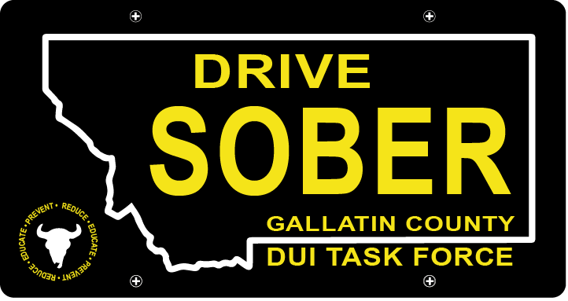

Gallatin County DUI Task Force

Meeting

Wednesday, May 17, 2022 @ 5:30 pm
Courthouse 3rd Floor Community Room: 311 West Main Street, Bozeman, MT

Join Zoom Meeting
Meeting ID: 878 1856 8292
Passcode: DUITF23

- Call to order
- Approval of Minutes
- Update
  - Member Update
  - DUI Statistics Report – Update
- Old Business
      - Annual Plan Review
    - Budget
      - Proposed Budget for Full-Time Coordinator
    - Review Goals and Priorities
- New Business
    - Events
      - Music on Main
      - Catapalooza – Volunteer Sign Ups
      - Brainstorm Other Event Ideas
    - Review Task Force Expectations and Commitment for Membership
- Public Comment
- Adjournment
Adjourned meeting at _________.

