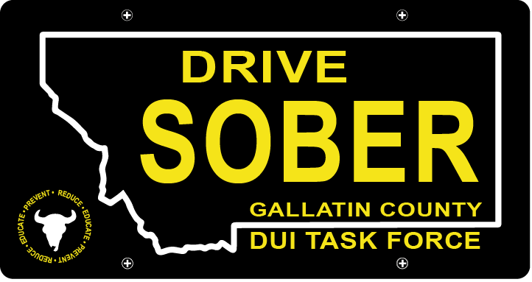

Gallatin County DUI Task Force

Meeting

March 17, 2021

Join Google Meet
https://meet.google.com/rhn-xnae-gxq

- Call to order
  - Coordinator, Leah Mobley
  - Virtual Introductions
    - New Members (WELCOME!)
    - Veteran Members
- Update – Leah Mobley, Coordinator
  - Think Twice- Forrest will be out here in March
    - Press release
  - DUI related legislation (HB 115)
    - Voted on 3/11 in House Judiciary
  - Promo video(s)
    - First Meeting
    - Reached out to MSU Professors to discuss students that might be interested in undertaking a project like this.
    - PI&E committee and anyone who wants to help with the project.
- New business
  - TikTok Competition for MSU vs. UM / Missoula County
    - Summary
  - Elections
    - Election process
    - Nomination (Executive Board expectations & responsibilities attached in the email as well)
- Election
  - Link will be sent out during meeting (Google Forms)
- Questions:
  - For new or veteran members.
- Adjournment
Leah Mobley adjourned the meeting at _________.

