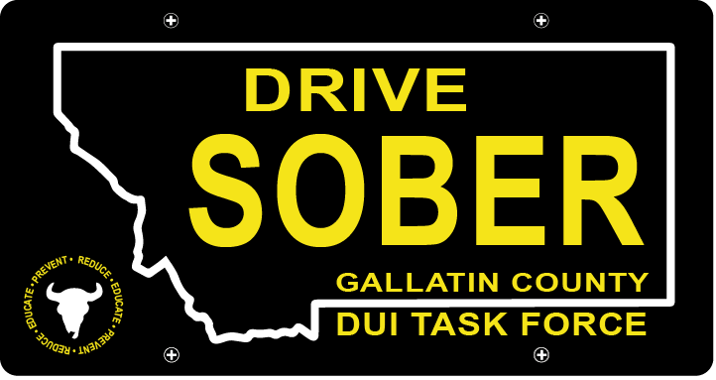

Gallatin County DUI Task Force

Meeting
Location: Law & Justice Center Rm, 205
Date: Wednesday, 3/18/2020
Time: 5:30 – 6:30
- Call to order
Leah Mobley, Coordinator
- Mission Moment
The mission of the Gallatin County DUI Task Force is to reduce the incidence of driving under the influence of alcohol and other drugs by being the “face of DUI prevention” by providing education, funding, networking opportunities, enforcement and public advocacy in Gallatin County. – Katy Fritz, Chair
- Consent Agenda
Approve Minutes from January Meeting. – Katy Fritz, Chair
- Brainstorm Session – Leah Mobley, Coordinator
  - Break into groups: tangible goals for the task force?
  - Survey
- New business
  - Upcoming Awards Ceremony 4/8
  - DUI Task Force Challenge Coins
  - Retractable Banner
  - Membership Removal of Jerry Pape
- PI & E Committee Update
  - Drivers Ed 2/13
- Adjournment
Leah Mobley adjourned the meeting at _________.

