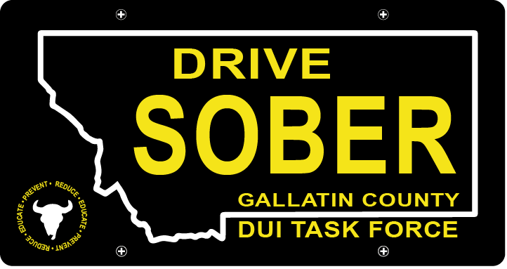

Gallatin County DUI Task Force

Meeting

March 16th, 2022 @ 5:30 pm

Gallatin County Attorney’s Office:
Or Online with link

1709 W. College St
Bozeman, MT
59715

- Call to order
  - Introductions
  - January Minutes Approval
- Update
  - Transition update
    - Job has been posted
    - Website started
  - Strategic Plan
  - Student Video Project
- New business
    - LE Award Ceremony
- Public Comment
- Adjournment
Adjourned meeting at _________.

