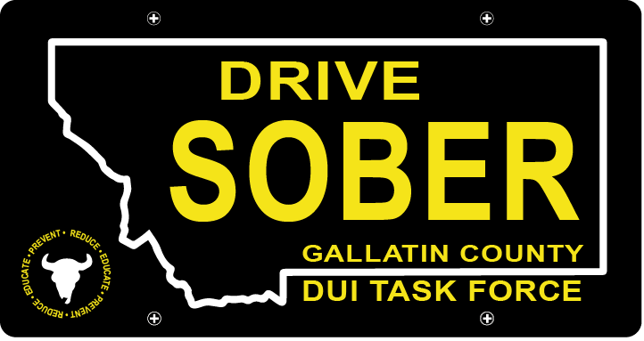

Gallatin County DUI Task Force

Meeting

Wednesday, March 15, 2022 @ 5:30 pm
Courthouse 3rd Floor Community Room: 311 West Main Street, Bozeman, MT

Join Zoom Meeting
Meeting ID: 473 409 9336
Passcode: DUITF23

- Call to order
- Approval of Minutes
- Update
  - Member Update
  - DUI Report – Update
  - CEASE Award Approval
- Old Business
    - Award Ceremony
      - Update
      - Date Change – Thursday, April 20th
      - Sponsors for Awards
      - Set-Up and Clean-Up
    - Budget
      - Proposed Budget for Full-Time Coordinator
- New Business
  - Bylaws Amendment
    - Timeline
    - Membership Structure
    - Suggestions/Updates
    - Strategic Planning
      - Planning for Next Year – Goals
- Public Comment
- Adjournment
Adjourned meeting at _________.

