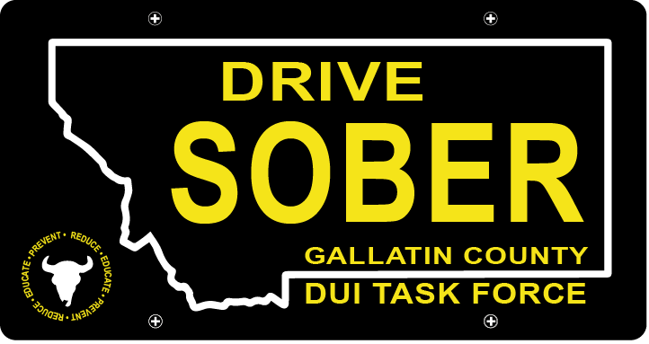

Gallatin County DUI Task Force

Meeting

July, 21st 2021

Gallatin County Attorney’s Office:
1709 W. College St
Bozeman, MT
59715

- Call to order
  - Coordinator, Leah Mobley
  - Introductions
  - May Minutes Approval
- Update – Leah Mobley, Coordinator
  - Vote on Bylaw Changes
    - Email sent out with attached changes
    - Will be sent off to county commissioners upon approval
    - Focusing on the video project for the summer, and securing the grant for that
  - Geo-fencing Uber discounts for local events
    - Music on Main
    - (Maybe) Belgrade Friday Night Races
    - Other ideas?
  - Future Events
    - Music on Main: July 22nd, 29th, August 5th, 12th
      - Volunteers needed
    - Catapalooza August 23th
      - Volunteers needed
    - Fall & Winter events to look out for
  - Drivers Ed, and crashed car update- Jon
  - Think Twice Update- Forrest McKai
- New business
  - Task Force moving forward
    - Committees
    - Volunteering
    - Events
- Public Comment
- Adjournment
Adjourned meeting at _________.

