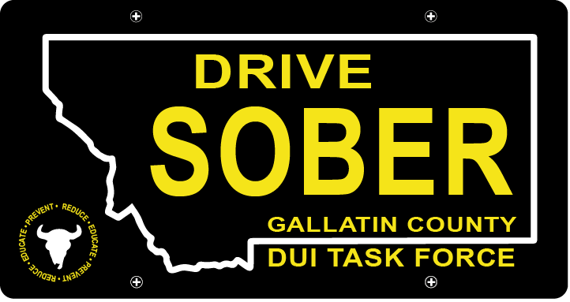

Gallatin County DUI Task Force

Meeting

July 20, 2022 @ 5:30 pm
Gallatin County Attorney’s Office: 1709 W College, Bozeman, MT Or Online with link
- Call to order
  - Coordinator, Anna Ewen
  - May Minutes Approval
- Update – Anna Ewen, Coordinator
  - Member Update
    - Frank Resigned
  - Summer Events
    - Music on Main
      - 1st one was on the 7th
      - Next ones are the 28th, the 4th and the 11th
      - Sign up for those on the sign-up genius or by emailing me
    - Manhattan Potato Festival
      - Saturday August 20th
      - Adding to the sign-up link
    - Catapalooza
      - Monday August 22nd
  - Award Banquet Donations
- New business
  - DUI Report
    - Update on where we are with that
    - Share first part of draft
- Public Comment
- Adjournment
Adjourned meeting at _________.

