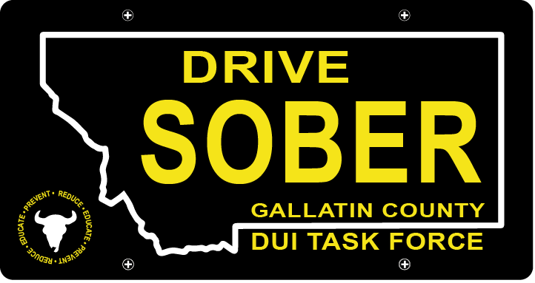

Gallatin County DUI Task Force

Meeting

Wednesday, July 19, 2022 @ 5:30 pm
Courthouse 3rd Floor Community Room: 311 West Main Street, Bozeman, MT

Join Zoom Meeting
Meeting ID: 473 409 9336
Passcode: DUITF23

- Call to order
- Approval of Minutes
- Update
  - Member Update
  - DUI Statistics Report – Update
  - Felony DUI Court Update
- Old Business
  - Events Update – Please sign up if you can!
    - Music on Main
      - July 27th and August 10th
    - Catapalooza
      - August 25th
    - New Event: Alpenglow Fest
      - August 25th and 26th
  - Montana Substance Abuse Prevention Academy – August 1-2
    - Hali and Michelle will be attending from the DUI Task Force
- New Business
- Public Comment
- Adjournment
Adjourned meeting at _________.

