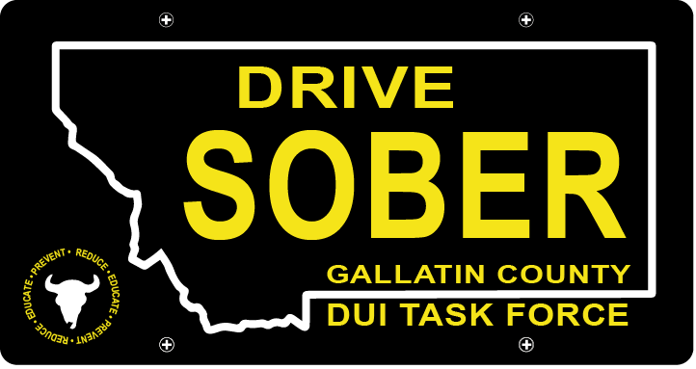

Gallatin County DUI Task Force

Meeting

January 20, 2021

Join Google Meet
https://meet.google.com/rhn-xnae-gxq

- Call to order
  - Coordinator, Leah Mobley
  - Virtual Introductions
    - New Members (WELCOME!)
    - Veteran Members
- Update – Leah Mobley, Coordinator
  - Think Twice
  - New Membership recruiting, numbers from the Commissioner’s Office
  - DUI related legislation (HB 115)
  - National DUI study mentioned Bozeman
- New business
  - Electing a new Executive Board (11 is quorum)
- 2021 Vision
  - Taking Ideas for new ways to reach the community with our message of preventing DUI
  - Events we should expect to be a part of this year.
  - Potential reconstruction of bylaws.
- Questions:
  - For new or veteran members.
- Adjournment
Leah Mobley adjourned the meeting at _________.

