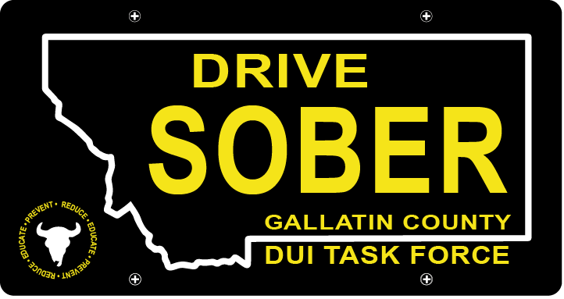

Gallatin County DUI Task Force

Meeting

Wednesday, January 18, 2022 @ 5:30 pm
Courthouse 3rd Floor Community Room: 311 West Main Street, Bozeman, MT

Join Zoom Meeting
Meeting ID: 473 409 9336
Passcode: DUITF22

- Call to order
- Approval of Minutes
- Update
  - Member Update
  - DUI Report – Update
  - CEASE Award Approval
- New business
    - January elections
      - Executive Committee Election Results
      - Executive Committee to determine positions
    - Task Force Structure Discussion
      - Strategic Plan + Budget
      - Brainstorm Goals
    - Membership
    - Award Ceremony
      - Have commitment from 4/7 departments
      - Sponsor Ideas
        - Sitka
        - Schnee’s
        - Mystery Ranch (just needs 90-day advance)
        - Other ideas?
      - Logistics: Date/Time/Location
    - 2023 Events
- Public Comment
- Adjournment
Adjourned meeting at _________.

